<https://www.themuse.com/coaching>

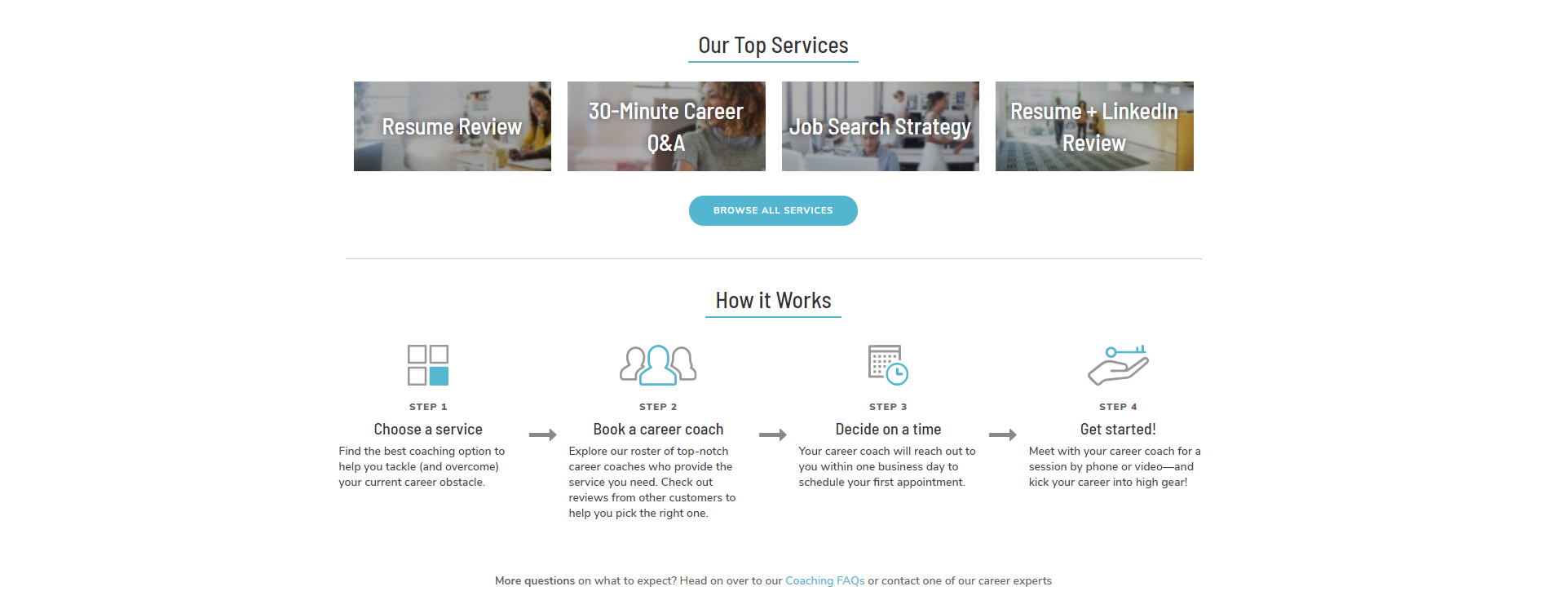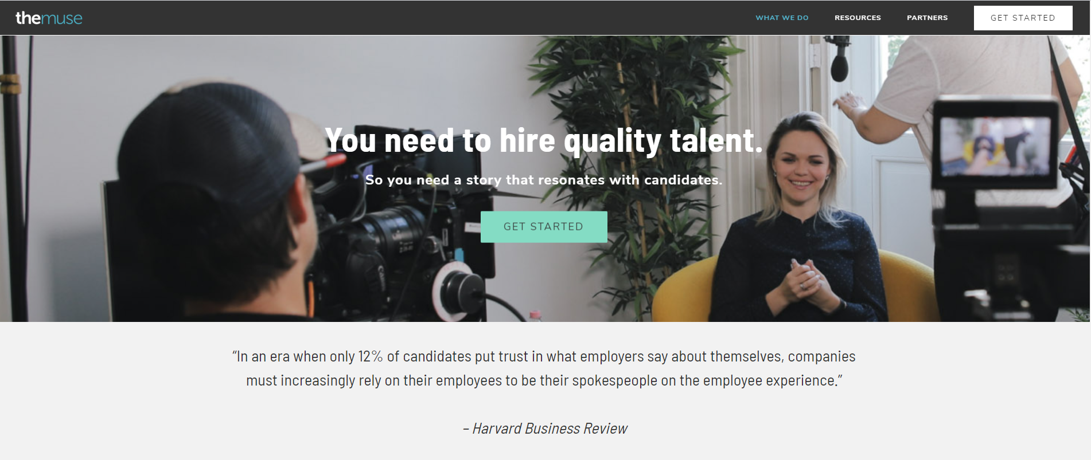

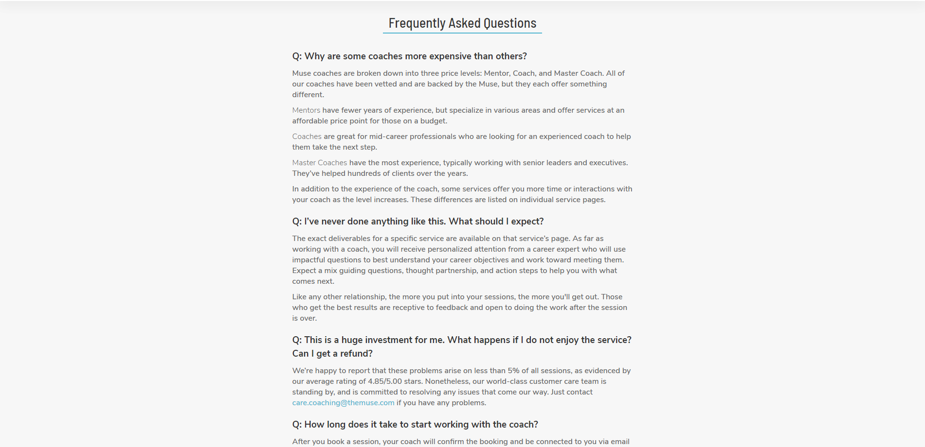

Service page Mock Interview by <br>Real life Interviewer

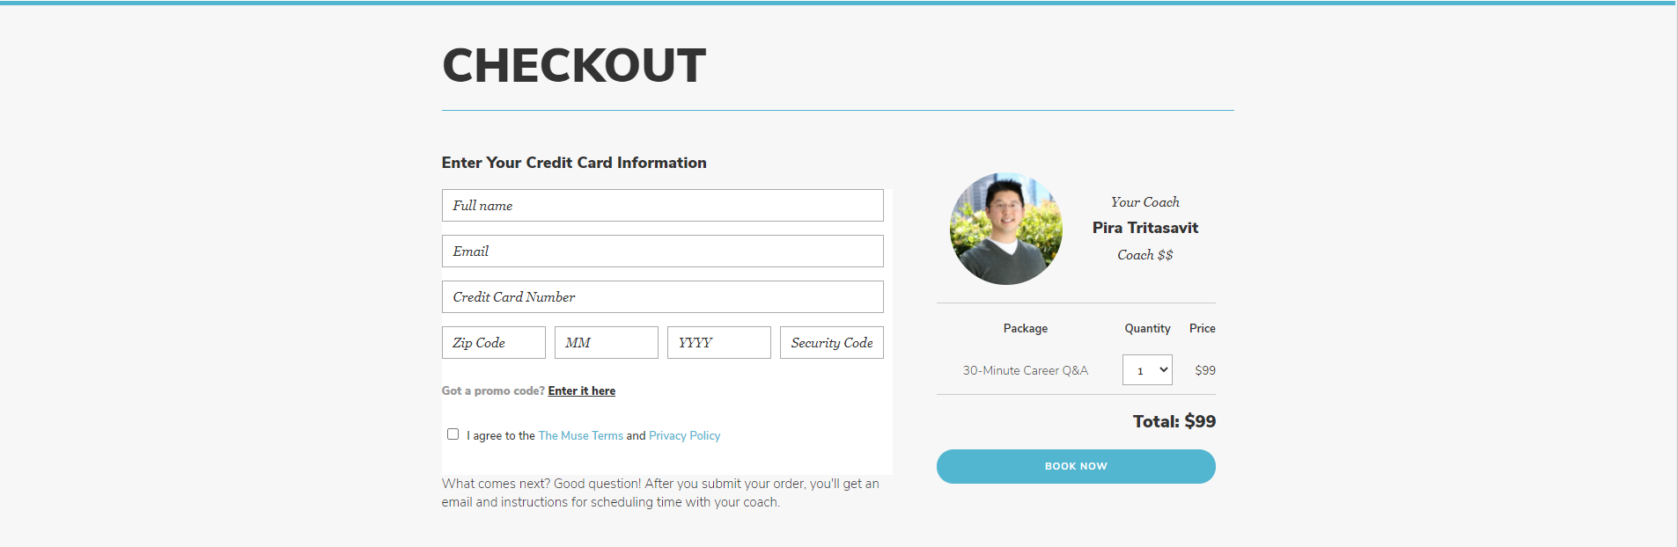check Out page

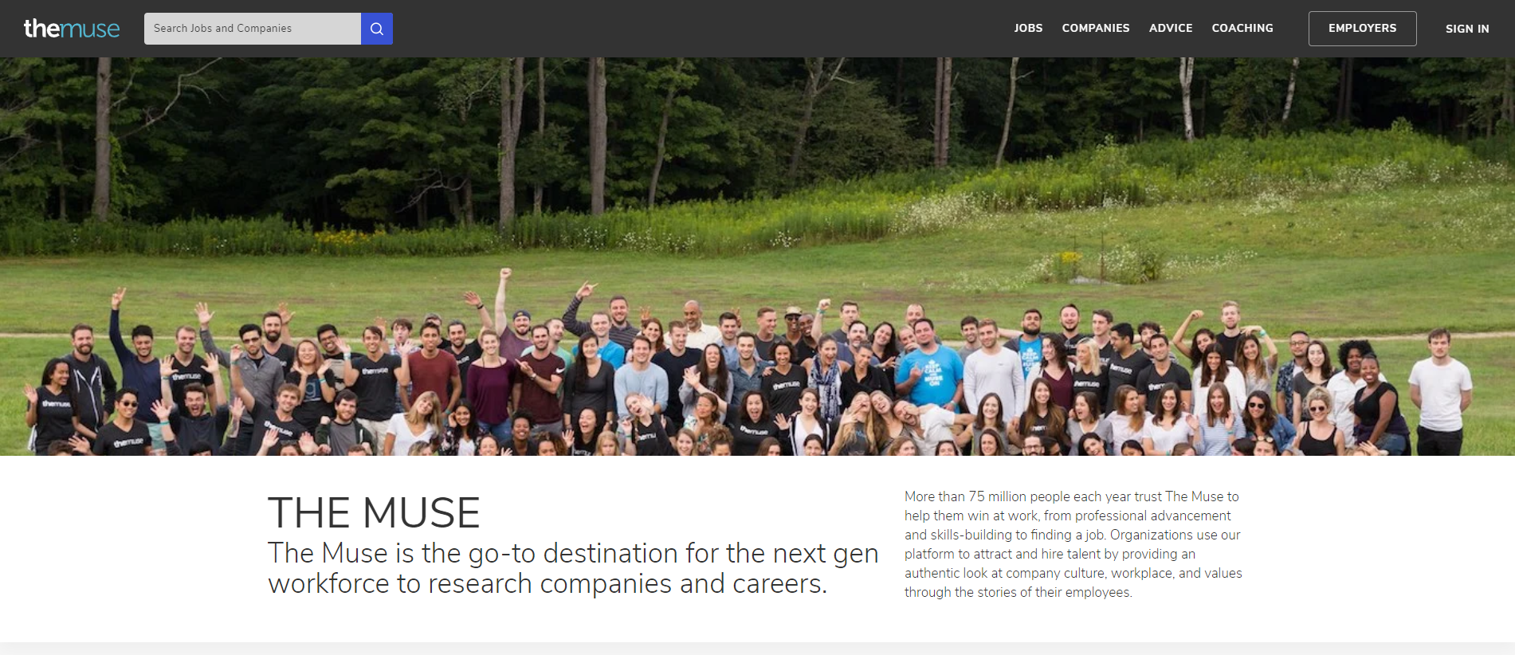About us

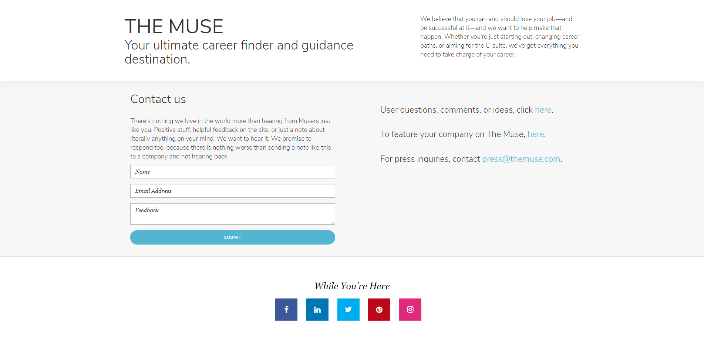Contact us

The Muse Terms of Use

Revised: January 13, 2020

1. **Introduction.**

Daily Muse Inc. (“The Muse”) is your ultimate career destination for exciting job opportunities, expert advice, a peek behind the scenes into fantastic employers, and access to amazing career coaches.

By creating an account or otherwise using the Services (as defined below) in any manner, you are entering into a legally binding agreement with The Muse, a Delaware corporation headquartered in New York, New York, as set forth in these Terms of Use (“Terms”). These Terms also include our [Privacy Policy](https://www.themuse.com/user/privacy) which is incorporated by reference.

You must be at least 16 years of age to use the Services. If you are under 16 years of age, you may not, under any circumstances or for any reason, use the Services. The Services are not targeted to or meant for anyone who has not reached 16 years of age and we will not knowingly collect information from anyone under the age of 16. If the applicable law in the country or state in which you are using the Services requires that you be older than 16 to use the Services, then you must be at least the minimum age legally defined for such country or state in order to use the Services.

1. **Services.**

The “Services” collectively include the “Website” (meaning [www.themuse.com](https://www.themuse.com/) and including all webpages, subdomains, and any successor or affiliated websites), emails, newsletters, and other communications, user accounts, job application services, Coach Connect Services, Content, any other products or services offered by The Muse, and any other services that state they are governed by these Terms. “Content” means any and all text, articles, images, videos, graphics, software, music, audio, information, or other materials appearing on the Website, including, without limitation, information about employers, career resources, advice, questions, answers, or other content, whether created or posted by you, The Muse, a third party, or any other user.

1. **Modifications.**

We may update these Terms from time to time. We will give you notice of the changes by posting an updated version of these Terms online, updating the “Revised” date above, or by emailing you at an email address you have provided. Changes to these Terms will be effective as of the date we post them or otherwise notify you of them, unless we specify a different effective date when we make a particular change. Your continued use of the Services will constitute your acceptance of the changes. If you do not agree to a change, you must stop using the Services.

We may modify, add to, suspend, or discontinue the Services or certain features of the Services, or remove any Content at any time for any reason, without prior notice to you. Unless expressly stated otherwise, any new feature that augments, enhances, or otherwise modifies the Services is subject to these Terms.

1. **Accounts.**

While you are not required to provide your personal information to us, unless you create an account with us (a “Muse Account”) and give us certain personal information, we may not be able to provide you with access to, or use of, some of the Services. If you choose not to create or continue to maintain a Muse Account, you may still access certain features as a visitor to our Website. Your access and use of the Services, whether as a visitor or as a Muse Account holder, is subject to these Terms.

Your Muse Account is for your personal, non-commercial use only and you must provide complete and accurate information when creating a Muse Account. You are responsible for maintaining the confidentiality and security of your account information, including any usernames or passwords, and are solely responsible for the activity that occurs on your Muse Account. You may not create an account for someone else or allow someone else to use your Muse Account. You agree to notify us immediately of any actual or suspected unauthorized access to or use of your username or password or any breach of security related to your Muse Account. If your Muse Account has been canceled by us, or you have been removed or otherwise blocked from the Website due to a violation of our Code of Conduct or for any other reason, you may not continue to use the Services.

You may cancel your Muse Account at any time by sending an email to [customer care](mailto:care.email@themuse.com). If your Muse Account is cancelled, we have no obligation to maintain, delete or return to you any Content or personal information data you have posted through your use of the Services unless you specifically request such deletion in accordance with our [Privacy Policy](https://www.themuse.com/user/privacy) and have a legitimate right to such deletion under applicable law.

1. **Job Applications.**

The Muse allows you to get an inside look at employers, browse open positions, and apply to jobs. Some job postings on our Website allow users who are logged into their Muse Accounts to complete and submit job applications directly through our Website. Other job postings on our Website will re-direct you to the applicable employer’s career page, where you will be able to submit an application without creating a Muse Account. Additionally, we may, but are not obligated to, provide your Muse Account with the option to save information for applying to jobs, such as a favorites list of employers, job openings to apply to later, and uploading a resume, cover letter, or other professional information. The collection of any such information is governed by our [Privacy Policy](https://www.themuse.com/user/privacy).

1. **Paid Services.**

The Services include a variety of products and services that are free to use (“Free Services”), as well as certain products and services that require payment (“Paid Services”). We reserve the right to charge for Free Services or change the price for Paid Services, at any time. If you purchase any of our Paid Services, you agree to pay us any applicable fees and taxes and you agree to any additional terms that may apply. You hereby authorize the collection of such amounts either directly by The Muse or indirectly via a third-party payment processor. Failure to pay these fees will result in the termination of the applicable Paid Service. If you are directed to a third-party payment processor, you may be subject to terms and conditions governing the use of that third-party’s service and that third-party’s personal information collection practices.

Please note that The Muse is not liable for any bank fees, foreign exchange fees, or differences in prices based on geographic location. The Muse or its third-party payment processor may store and continue billing your payment method in order to charge you for other Paid Services you may buy.

1. **Content; Licenses.**
   1. **Your Content.** We do not acquire ownership of the Content you post through the Services, but by posting any Content, you agree to grant us a universal, perpetual, sub-licensable, commercial, royalty-free, and irrevocable license to use, copy, reproduce, process, adapt, modify, create derivative works from, publish, transmit, display, and distribute such Content, in all media and distribution methods now known or hereafter devised, and you represent to us that you have the right to grant such a license. You agree that this license includes the right for other users of the Services to modify your Content and for The Muse to make your Content available to others for the publication, distribution, syndication, or broadcast on other media and services. Such additional uses by The Muse or others may be made with no compensation paid to you with respect to the Content that you submit, post, transmit, or otherwise make available through the Services. Any feedback, comments, or suggestions you may provide regarding the Services is entirely voluntary and we are free to use such feedback, comments, or suggestions as we see fit and without any obligation to you. We reserve the right, but do not have any obligation to, remove or block any Content in our sole discretion, at any time, without notice to you and for any reason (including, without limitation, upon receipt of claims or allegations from third-parties or authorities relating to such Content or if we are concerned that you may have violated these Terms), or for no reason at all. If the Content you submit to the Services contains your personal information, your right to access that personal information is governed by our [Privacy Policy](https://www.themuse.com/user/privacy).
   2. **The Muse Content.** The Website and Services also contain Content posted by The Muse and our licensors (“Muse Content”). We and our licensors retain all right, title and interest in and to such Muse Content, including all associated intellectual property rights, including, without limitation, copyrights, trademarks, trade names, trade dress, logos, patents, know-how, trade secrets, instructions, and all other proprietary information. Subject to your compliance with these Terms, The Muse grants you a revocable, limited, non-exclusive, non-transferable license, to access and view any Muse Content solely for your personal and non-commercial purposes. You agree not to sublicense, copy, distribute, display, disseminate, reproduce, or otherwise exploit any Muse Content or Services without our prior written permission, regardless of whether it is created or owned by The Muse or a licensor to The Muse.
   3. **Trademarks.** The trademarks, logos, trade names, and service marks, whether registered or unregistered (“Trademarks”) displayed on the Website are Trademarks of The Muse and its third-party licensors. Display or use of any Trademarks on the Website or in the Services shall not be construed as granting, by implication or otherwise, any license or right to use any Trademark without the prior written permission of The Muse or such third-party. You also agree not to use our trade dress, or copy the look and feel of the Website or its design.
   4. **Disclosure of Content.** We reserve the right to access, read, preserve, and disclose any Content or information in accordance with our [Privacy Policy](https://www.themuse.com/user/privacy).
2. **Coach Connect Services.**

Coach Connect is a Paid Service that can connect you with qualified career coaches (“Coach” or “Coaches”). You may purchase a variety of different Services offered by Coaches (“Coach Connect Services”), including, among others, resume review, career Q&A, and job search strategy.

Coaches are independent career consultants who offer consulting services for users of Coach Connect. They are not employees or agents of The Muse and we do not endorse or verify any Coaches or the Coach Connect Services provided by any Coach. The Coaches, and not The Muse, are solely responsible for honoring any Coach Connect Services purchased by you. If a Coach becomes unavailable to provide a purchased Coach Connect Service, you may be entitled to a refund. If you miss an appointment or fail to give at least 24 hours-notice of cancellation, the fees you paid for the Coach Connect Service may be forfeited. Please [click here](https://www.themuse.com/coaching#coach-faq-anchor) to see frequently asked questions about the Coach Connect Services including more information about cancellation policies. Except for the circumstances specified in these Terms, Coach Connect Services are non-refundable.

Coach Connect Services must be purchased in advance, and may be purchased individually or in packages. We will honor the price of a Coach Connect Service purchased for a period of 12 months from the date of purchase, even if we decide, in our sole discretion, to otherwise increase the price of such Coach Connect Service during that period. The Muse will not honor purchased Coach Connect Services which are not used within 12 months from the date of purchase.

Payments made for Coach Connect Services are transferred to the applicable Coach promptly following completion of the relevant Coach Connect Service, less any service fees charged by The Muse and any processing fees, if applicable.

For so long as The Muse offers Coach Connect Services, you hereby agree not to hire or otherwise engage any Coach to whom you are introduced via the Website other than directly through the Website. To the extent you breach the foregoing restriction, you and the applicable Coach shall be jointly and severally liable for any losses incurred by us as well as liquidated damages in the amount of $150 per breach, and The Muse will have no obligations or liability whatsoever in respect of any such engagements.

1. **Links to Third-Party Sites.**

The Website may direct you to third-party websites that are not owned or maintained by The Muse. We are not responsible for your use of such third-party websites and we make no representations whatsoever concerning the content or accuracy of, opinions expressed in, or other links provided by such websites. The inclusion of any such link to a third-party website does not imply any association between us and their operators. Your use of any third-party websites is governed by the terms of such third-party websites and not by these Terms.

1. **Code of Conduct.**

You understand and agree that you are solely responsible for compliance with any and all laws, rules, regulations, and tax obligations that may apply to your use of the Services. In connection with your use of the Services, you agree that you will not:

* 1. Violate any local, state, provincial, national, or other law or regulation, or any order of a court.
  2. Run any bots, spiders, scrapers, web crawlers, indexing agents, or other software to aggregate or browse our Services, including, without limitation, company or user accounts or profiles, or otherwise interfere with or circumvent the integrity of the Website or Services.
  3. Introduce any viruses, trojan horses, worms, time bombs, cancelbots, corrupted files, or similar software to the Website or Services or transmit any other computer programming routines that may damage, interfere with, or surreptitiously intercept any data, or personal information.
  4. Use the Services to transmit, distribute, post, or submit any confidential information concerning any other person or entity.
  5. Stalk or harass, interfere with, or disrupt the access of any user of the Services, or collect or store any personally identifiable information about any other user without explicit consent from the user.
  6. Defame, defraud, mislead, or impersonate any person or entity, or otherwise misrepresent yourself or your affiliation with any person or entity.
  7. Post false information, including, without limitation, in respect of a job, company, or your own credentials as a job applicant.
  8. Infringe, violate, or otherwise interfere with any copyright, trademark, or other intellectual property rights of another party.
  9. Act in any manner which, in our sole discretion, is objectionable, interferes with the proper working of the Services, or which may affect our reputation in any way.

1. **Disclaimers.**

The disclaimers in this section apply to the maximum extent allowable under applicable law.

You are solely responsible for your use of the Services and we are not responsible for the activities, omissions, or other conduct, whether online or offline, of any other user or any Coach. You are solely responsible for ensuring that your use of the Services is in compliance with all laws, rules, and regulations applicable to you. We make no representations concerning any Content contained in or accessed through the Services.

The Services are provided “as is” and without warranty of any kind, whether express or implied, including the warranties or conditions of merchantability, fitness for a particular purpose, accuracy, or non-infringement, all of which are expressly disclaimed. The Muse does not warrant that: (a) the Services will be secure or available at any particular time or location; (b) the Services will function without errors; (c) any defects or errors will be corrected; (d) any Content or software available through the Services is free of viruses or other harmful components; and (e) the results of using or relying on any Content or Services or advice contained therein will meet your requirements or produce desired results. Your use of, or reliance on, the Services or any Content is solely at your own risk.

1. **Limitation of Liability.**

TO THE MAXIMUM EXTENT PERMITTED BY APPLICABLE LAW, IN NO EVENT SHALL THE MUSE BE LIABLE TO YOU OR ANY THIRD PARTY FOR ANY LOST PROFITS OR ANY INDIRECT, CONSEQUENTIAL, EXEMPLARY, INCIDENTAL, SPECIAL, OR PUNITIVE DAMAGES, OR ANY LOSS OF DATA, OPPORTUNITIES, OR REPUTATION ARISING FROM YOUR USE OF THE WEBSITE, CONTENT, OR SERVICES, EVEN IF WE HAVE BEEN ADVISED OF THE POSSIBILITY OF SUCH DAMAGES. NOTWITHSTANDING ANYTHING TO THE CONTRARY CONTAINED HEREIN, UNLESS OTHERWISE REQUIRED BY APPLICABLE LAW, YOU AGREE THAT IN NO EVENT SHALL THE AGGREGATE LIABILITY OF THE MUSE, WHETHER IN CONTRACT, WARRANTY, TORT (INCLUDING NEGLIGENCE, WHETHER ACTIVE, PASSIVE, OR IMPUTED), PRODUCT LIABILITY, STRICT LIABILITY, OR OTHER THEORY, ARISING OUT OF OR RELATING TO THE USE OF OR INABILITY TO USE THE SERVICES EXCEED THE AMOUNT PAID BY YOU, IF ANY, FOR ACCESSING THE SERVICES DURING THE TWELVE (12) MONTHS IMMEDIATELY PRECEDING THE DATE OF THE CLAIM OR ONE HUNDRED DOLLARS, WHICHEVER IS GREATER.

1. **DMCA Notices.**

We respect the intellectual property rights of others and take copyright infringement seriously. We have registered a Copyright Agent with the United States Copyright Office, which limits our liability under the Digital Millennium Copyright Act. If you believe that your copyright has been infringed on the Website or otherwise in our Services, please notify us via mail or email with a message which contains:

* 1. Your name and contact information, including your address, telephone number, and an email address;
  2. The name of the party whose copyright has been allegedly infringed, if different from your name;
  3. The name and description of the original work that is allegedly being infringed;
  4. The location of the alleged infringing copy (such as the URL);
  5. A statement that you have a good faith belief that use of the copyrighted work is not authorized by the copyright owner (or by a third-party who is legally entitled to authorize its use on behalf of the copyright owner) and is not otherwise permitted by law; and
  6. A statement that you swear, under penalty of perjury, that the information contained in the notification is accurate and that you are the copyright owner or have an exclusive right in law to bring infringement proceedings with respect to its use.

You must sign this notification and send it to our Copyright Agent at:

Attn: Legal  
Daily Muse Inc.  
1375 Broadway, 20th Floor  
New York, New York 10018  
United States  
[legal@themuse.com](mailto:legal@themuse.com)

We review all infringement claims, determine their merit, and act accordingly.

1. **Indemnification.**

You agree to indemnify, defend and hold harmless The Muse, its affiliates and each of their respective principals, shareholders, agents, officers, directors, consultants, and employees from or against third-party claims, damages, payments, deficiencies, fines, judgments, settlements, liabilities, losses, costs, and expenses arising from or relating to any third-party claim, suit, action or proceeding arising out of or related to your use or purchase of the Services, your violation of the rights of any third-party or person, or your breach of these Terms or any representation or warranty contained herein. The Muse reserves the right, at your expense, to assume the exclusive defense and control of any matter for which you are required to indemnify The Muse, and you agree to cooperate with The Muse’s defense of these claims. The Muse will use reasonable efforts to notify you of any such claim, action, or proceeding upon becoming aware of it.

1. **Dispute Resolution.**

You agree that the laws of the State of New York, USA, excluding its conflict of laws rules, shall exclusively govern any dispute relating to these Terms and/or the Services.

PLEASE READ THE FOLLOWING PARAGRAPH CAREFULLY BECAUSE IT REQUIRES YOU TO ARBITRATE DISPUTES WITH THE MUSE AND LIMITS THE MANNER IN WHICH YOU CAN SEEK RELIEF FROM THE MUSE. ARBITRATION PREVENTS YOU FROM SUING IN COURT OR FROM HAVING A JURY TRIAL.

You and The Muse agree to arbitrate any dispute arising from these Terms or your purchase or use of the Services, except that you and The Muse are not required to arbitrate any dispute in which either party seeks equitable and other relief for the alleged unlawful use of copyrights, trademarks, trade names, logos, trade secrets, or patents. You and The Muse agree that you will notify each other in writing of any dispute within thirty (30) days of when it arises. Notice to The Muse shall be sent by mail to Daily Muse Inc., Attn: Legal, 1375 Broadway, 20th Floor, New York, New York 10018 or by email to [legal@themuse.com](mailto:legal@themuse.com). You and The Muse further agree: to attempt informal resolution prior to any demand for arbitration; that any arbitration will occur in New York, New York; that arbitration will be conducted confidentially by a single arbitrator in accordance with the rules of JAMS; and that the state or federal courts in New York, New York have exclusive jurisdiction over any appeals of an arbitration award and over any suit between the parties not subject to arbitration. Other than class procedures and remedies discussed below, the arbitrator has the authority to grant any remedy that would otherwise be available in court. Whether the dispute is heard in arbitration or in court, you and The Muse will not commence against the other a class action, class arbitration, or other representative action or proceeding.

1. **Miscellaneous.**

These Terms, together with the [Privacy Policy](https://www.themuse.com/user/privacy), and any other legal notices published on the Website, shall constitute the entire agreement between you and The Muse concerning your use of the Services. These Terms, and any rights and licenses granted hereunder, may not be transferred or assigned by you, but may be assigned by The Muse at any time without restriction. If any provision of these Terms is deemed invalid by a court of competent jurisdiction, the invalidity of such provision shall not affect the validity of the remaining provisions of these Terms, which shall remain in full force and effect. If two or more provisions of this Agreement are deemed to conflict with each other’s operation, The Muse shall have the sole right to elect which provision remains in force. No waiver of any one provision set forth in these Terms shall be deemed a further or continuing waiver of such provision or any other provision, and The Muse’s failure to assert or enforce any right or provision under these Terms shall not constitute a waiver of such right or provision.

Any inquiries about your rights under these Terms, or any matters regarding your privacy, can be directed to [terms@themuse.com](mailto:terms@themuse.com), [privacy@themuse.com](mailto:privacy@themuse.com), respectively, or by mail to:

Attn: Legal  
Daily Muse Inc.  
1375 Broadway, 20th Floor  
New York, New York 10018

# The Muse Privacy Policy

## Revised January 13, 2020

Daily Muse Inc. (“The Muse”) respects the privacy of our users. This privacy policy (the “Privacy Policy”) describes how we collect, use, store, and disclose information in connection with our Services and with our Website. By accessing our Website and/or using our Services, you agree to the provisions of this Privacy Policy and to our [Terms](https://www.themuse.com/user/terms). Unless otherwise defined herein, capitalized terms have the meanings defined in the [Terms](https://www.themuse.com/user/terms).

Please note that except as otherwise described below, this Privacy Policy does not apply to the processing of any information by third parties. For example, when users seek to apply to a job notice, the Services may redirect the user to an Employer’s career site to submit an application. Information collected through such a third-party site is not subject to this Privacy Policy, but is instead subject to the third-party’s privacy policy. Similarly, information that users submit directly to a Coach is not covered by this Privacy Policy.

## Who Uses Our Services

We make our Services available to different types of users. As discussed further below, the information that the Services collect from and share about a user may depend on the user type. An individual may be one or more of these types of users depending on the nature of the individual’s interactions with our Services.

* **Member:** An individual who uses the Services.
* **Author:** An individual who drafts articles, posts content or creates other content displayed on the Website.
* **Coach:** An individual who offers Coach Connect Services through the Website as a career counselor or job coach.
* **Employer:** An entity that has a company profile on the Website or otherwise has services provided to it by The Muse.

## Information We Collect

We collect certain information about users, including Personal Information, in order to fulfill our lawful business interests, including in connection with the Services. “Personal Information” is any information related to an identified or identifiable person, including by reference to an identifier such as a name, location data, email address or phone number, or other factors specific to a person’s identity. We collect only the information necessary to fulfill our lawful business interests, and keep your information only as long as is necessary to fulfill those interests. We may combine Personal Information with other information, in which case we will treat the combined information as Personal Information. We also may combine information that we collect about you through the Services with additional information that we or third parties collect in other contexts—such as our communications with you via email or phone, or our customer service records. In those circumstances, we will treat the combined information in accordance with this Privacy Policy.

You can visit the Website and use some of the Services without providing any information, including Personal Information. However, if you choose not to provide Personal Information, we may not be able to provide you with full access to, or use of, the Services. As described below, we do automatically collect certain information when you use the Services. The Services also require you to provide Personal Information when you register as a Member, Coach, Author, or Employer. If you connect to the Website through LinkedIn or other third-party social media platforms, please also review the Social Media Information below.

**Information about Members.** We collect various types of Personal Information about Members in connection with the Services, which may include: name, mailing address, email address, username and password, work and educational history, company and job title, photograph, other information contained on Members’ resumes, content posted by Members, information about which jobs Members apply to through the Services, location information, and payment information.

**Information about Coaches and Authors.** We collect various types of Personal Information about prospective and current Coaches and Authors, which may include: name, mailing address, email address, phone number, username and password, work and educational history, company and job title, photograph, content posted by Coaches or Authors, and financial account information. We may ask for additional information about Coaches or Authors in order to determine whether they are a good fit for the Services. Information may be requested through such means as applications, telephone screenings, and reference checks. The Muse makes some of the information about Coaches and Authors available to Members and/or the public for the purpose of providing the Services. We also collect and retain rating information provided by Members about Coaches at the completion of a Coaching Session.

**Information about Employers.** We collect various types of Personal Information about Employers, which may include: name, mailing address, email address, phone number, username and password, content posted or submitted by Employers, and Personal Information of their employees. The Muse may make certain Employer information identified above available to Members and/or the public for the purpose of providing the Services.

**Applicant Information.** We may also receive Personal Information, including job applicant data from Employers and applicant tracking systems as well as through Employers’ purchase of Services on your behalf.

**Social Media Information.** You may choose to log in to the Website using a third-party social media service, such as LinkedIn. If you do so, we may collect Personal Information from the social media provider, including, for example, your username, email address, and available profile information, such as your public profile URL, profile photo, connections, industry, and location, as well as other information associated with your social media account. We require your consent prior to you accessing the Website from your social media account. If you provide such consent, you represent and warrant that you satisfy the terms regarding such accounts and have the authority to provide us with information about your social media connections.

**Surveys.** From time to time, we may ask users to participate in surveys, contests, promotions, and sweepstakes which may be used to collect Personal Information. Participation is completely voluntary and declining to participate will not impact your use of the Services.

**Payment Information** We collect certain payment and billing information when you purchase Services. You might also provide payment information which we collect via secure payment processing services.

**Other information collected automatically through the Services.** We also collect information automatically through the Services. This may include information such as your IP address and domain name, your location as inferred from your IP address, your Internet service provider, the date and time of your visit to the Website, your use of the Services during your current session and over time (including the pages you view and the files you download), the URLs from the websites you visit before and after navigating the Website, your computer’s and/or mobile device’s operating system and browser type, and your software and hardware attributes (including device IDs). We collect such information using a variety of mechanisms, including the following:

* Server Logs. When you visit the Website, we automatically receive and record certain information from your computer (or other devices) and your browser. This may include data such as your IP address, the web pages you visit, or features you use on the Website, and your general geographic location as inferred from your IP address. To obtain such information, we may use server logs or similar applications that recognize your computer or other devices and gather information about their online activity.
* Cookies. Cookies are small files that are stored on your computer or other device by your web browser. We use cookies in providing the Services. A cookie allows the Services to recognize whether you have visited before and may store user preferences and other information. For example, cookies can be used to collect information about your use of the Services during your current session and over time (including the pages you view and the files you download), your computer or device’s operating system and browser type, your Internet service provider, your domain name and IP address, your general geographic location, and the website you visited before and after accessing the Services. If you are concerned about having cookies on your computer, you can set your browser to refuse all cookies or to indicate when a cookie is being set, allowing you to decide whether to accept it. You can also delete cookies from your computer. However, if you choose to block or delete cookies, certain features of the Website may not operate correctly. We use the following types of cookies to collect information:
  + Essential Cookies: These cookies are essential to the functioning of the Services and allow you to interact with and use the features of the Services. If these cookies are not permitted by your browser, we cannot provide certain Services to you.
  + Preference Cookies: These cookies are used to collect information about your choices and preferences, such as your preferred language or the country from which you access our Services. We use this information to customize your Services.
  + Analytics Cookies: Our third-party service providers may use cookies to collect information about you and the use of the Services for analytics purposes. For more information and to opt out, please read the section below titled “Third-Party Analytics and Targeted Advertising.”

Advertising Cookies: The Services may use cookies to make advertising messages more relevant to you. For more information and to opt out, please read the section below titled “Third-Party Analytics and Targeted Advertising.”

* Pixel tags. The Services may use an application known as a “pixel tag” (also known as a “clear gif” or “web beacon”). A pixel tag is an electronic file that usually consists of a single-pixel image. It can be embedded in a web page or in an email to transmit information, which could include Personal Information. For example, it allows an email sender to determine whether a user has opened a particular email. Deleting or blocking cookies will not stop the collection of information through pixel tags and similar tracking mechanisms. However, as discussed in the section below titled “Third-Party Analytics and Targeted Advertising,” you can take steps to limit how such information is used for advertising purposes. Even in that event, we may continue to use the information for other purposes, including analytics.
* Local storage. We also may use HTML5 local storage to collect and retain certain information about you. Data in local storage is not deleted when you clear your cookies, but it can be deleted by following the instructions provided by your browser developer.

**Information collected on third-party sites.** In some cases, we use the mechanisms described above to track users when they navigate to and on third-party sites. For example, we may use cookies, pixels, scripts, or other tracking mechanisms to identify when a user of the Services goes to the website of one of our business partners and applies for a job. This information enables us, among other things, to analyze how many applicants for a specific position learned about it on The Muse. Although we do not disclose Personal Information combined with such tracking data to our business partners, we may provide de-identified information and analytics as discussed in the section below titled “How We Share Information with Third Parties.”

## How We Use Information

We use the Personal Information that we collect about users, including Members, Coaches, Authors, and Employers, to:

* Provide the Services and create a custom experience for users and tailor our Services to users’ individual interests and preferences;
* Fulfill the terms of any agreement you have with us, respond to your requests, or otherwise complete a transaction that you initiate, including payment processing;
* Review, evaluate, and verify the credentials and experience of Coaches, including through screenings and reference checks;
* Post job notices and other company information for Employers;
* Transmit or redirect Members’ job applications to Employers;
* Communicate with users through email notices, newsletters, and updates, including promotional communications about topics, products, jobs, and Services that we believe will be of interest to users;
* Administer surveys, contests, or promotions;
* Engage in analysis and research concerning the Services, improve users’ experiences with the Services, and otherwise enhance the quality of our products and Services;
* Comply with legal and/or regulatory requirements, or to protect our rights and interests, as described below in the “Legal Purposes” subsection of this Privacy Policy;
* Compile and share aggregated information;
* Count and recognize visitors to the Services and analyze how visitors use the Services;
* Engage in analytics or targeted advertising as described in the “Third-Party Analytics and Targeted Advertising” section below; and
* For any other business purpose permitted by law.

## How We Share Information with Third Parties

The Muse may share information with third parties for a variety of purposes. We share information with the following third parties and in the following ways:

**Affiliates.** We may share information, including Personal Information, with our corporate affiliates for the purposes described in this Privacy Policy.

**Service providers.** We use third-party service providers to help us manage and improve the Services. We provide these parties with only the information they need to perform their services and work closely with them to ensure that your privacy is respected and protected. These service providers may collect and/or use your information, including Personal Information, to assist us in providing Services and in achieving the purposes discussed in this Privacy Policy. For example, we integrate certain plug-ins offered by third-party service providers. Even if you do not click on these plug-ins, they may collect information about you, such as your IP address. They also may set and/or access cookies. These plugins, including the Google Maps API, are governed by the privacy policy of the company providing them.

**Other users of the Services.** We may share information, including Personal Information, with other users of the Services where appropriate. For example, if you submit information to us or complete an application, we may share that information with an Employer who will evaluate your application. Similarly, we may share a Member’s contact information with a Coach to enable them to communicate directly.

**Business partners.** We also may share your information, including Personal Information, with our business partners to fulfill your requests for the Services; complete a transaction that you initiate; or meet the terms of any agreement that you have with us or our business partners.

**Your direct sharing of Personal Information through the Services and third-party websites and services.** The Services may enable you to share Personal Information directly through the Services or through a third-party. For example, the Services may allow a Member to upload a resume or job history to share with an Employer through the Website or post Content or career related questions on a forum. The Services may also provide a text-based or chat communication platform to connect Members and Coaches. In addition, the Services may contain links to third-party websites that incorporate comment and social media features, including the Facebook “like” button and the Twitter “follow” button. If you choose to use these features, you may disclose your Personal Information not just to those third-party websites and services, but also to their users and the public more generally. Because these third-party websites and services are not operated by The Muse, we are not responsible for the content or practices of those websites or services. The collection, use, and disclosure of your information will be subject to the privacy policies of the third-party websites or services, and not this Privacy Policy.

**Legal purposes.** We also may use or share your information, including Personal Information, with third parties when we believe, in our sole discretion, that doing so is necessary:

* To comply with applicable law or a court order, subpoena, request from government or law enforcement, or other legal process;
* To investigate, prevent, or take action regarding illegal activities, suspected fraud, or situations involving threats to our property or the property or physical safety of any person or third party;
* To establish, protect, or exercise our legal rights or defend against legal claims; or
* To facilitate the financing, securitization, insuring, merger, acquisition, sale, assignment, bankruptcy, or other disposal of all or part of our business or assets. In the event of an actual sale, merger, reorganization, dissolution or similar event relating to all or a portion of our business or assets, your information, including Personal Information, may be part of the transferred assets.

**De-identified or aggregated information.** We also may compile and share de-identified or aggregated information about users of the Services, such as by publishing a report on trends in the usage of the Services or sharing aggregated information about historical and real-time trends in employment.

## Third-Party Analytics and Targeted Advertising

We partner with certain third parties to collect information to engage in analytics, auditing, research, and reporting. These third parties may use web logs, pixel tags, or similar online tracking mechanisms, and they may set and access cookies on your computer or other device. For example, as discussed above, Employers may use pixel tags or scripts supplied by The Muse to track when users navigate to their websites and submit job applications.

Among other providers, the Services use [Google Analytics](https://www.google.com/analytics/learn/privacy.html) to help collect and analyze certain information for the purposes discussed above. You may opt out of the use of cookies by Google Analytics [here](https://tools.google.com/dlpage/gaoptout).

The Services may also enable third-party tracking mechanisms to collect information on our Services over time and across unaffiliated websites for use in online behavioral advertising. For example, third parties may use the fact that you visited the Website to target online ads for the Services to you on websites that are not affiliated with The Muse. In addition, our third-party advertising partners might use information about your use of the Services to help target advertisements unrelated to The Muse based on your online behavior in general. For information about behavioral advertising practices, including privacy and confidentiality, visit the websites for the [Network Advertising Initiative](http://www.networkadvertising.org/understanding-online-advertising) and the [Digital Advertising Alliance](http://www.aboutads.info/).

The use of online tracking mechanisms by third parties is subject to those third parties’ own privacy policies, and not this Privacy Policy. If you prefer to prevent third parties from setting and accessing cookies on your computer, you may set your browser to block cookies. Additionally, you may remove yourself from certain targeted advertising by using the opt-outs offered by: [Network Advertising Initiative](http://optout.networkadvertising.org/?c=1); [Digital Advertising Alliance](http://optout.aboutads.info/?c=2&lang=EN); [TRUSTe's opt-out tool](https://preferences-mgr.truste.com/" \t "_blank); [The Digital Advertising Alliance of Canada](http://youradchoices.ca/choices) (for users in Canada); and [European Interactive Digital Advertising Alliance](http://www.youronlinechoices.eu/) (for users in the EU).

## Security

The Muse uses physical, electronic, and procedural safeguards to protect your information against loss or unauthorized access, use, modification, or deletion. However, no security program is 100% secure, and thus we cannot guarantee the absolute security of your information.

## Your Choices and Access to Information

Depending on your location, including the European Economic Area and the United Kingdom, and where applicable law requires, you may have the following rights with respect to your Personal Information:

* to access your Personal Information;
* to update your Personal Information by emailing us or, where appropriate, amending the personal details contained in your registered account with us. If practically possible, we will make corrections based on your updated information;
* to withdraw your consent with respect to Personal Information that is collected on the basis of your consent;
* to request deletion of your Personal Information or object to its processing; and
* to lodge a complaint with us or, as applicable, with a supervisory authority.

If you want to learn more about the Personal Information that The Muse has about you, or you would like to exercise your choices regarding your Personal Information, please contact us by email at [privacy@themuse.com](mailto:privacy@themuse.com) or by mail at the address in the “Questions or Comments” section below.

If you no longer want to receive marketing communications from The Muse, please follow the “unsubscribe” instructions that are included at the bottom of each message. Please note that if you unsubscribe from our marketing communications, you will still receive administrative messages.

Due to technical reasons there may be a delay in accessing or deleting your Personal Information from our systems if you request it. We also will retain Personal Information in order to comply with the law, protect our and others’ rights, resolve disputes or enforce our legal terms or policies, to the extent permitted under applicable law.

## Transfer of Information to the United States

The information that we collect through or in connection with the Services is transferred to and processed in the United States for the purposes described above. The Muse also may subcontract the processing of your data to, or otherwise share your data with, affiliates or third parties in the United States or countries other than your country of residence. The data-protection laws in these countries may be different from, and less stringent than, those in your country of residence. By accepting this Privacy Policy, using the Services, or providing information to us, you expressly consent to such transfer and processing.

## Children’s Privacy

The Services are not directed to children under the age of 16, and The Muse does not knowingly collect Personal Information or other Information from anyone under the age of 16. If you are under age 16 you may not, under any circumstances or for any reason, use the Services.

## California Privacy Rights

This section provides additional details about the Personal Information we collect about California users and the rights afforded to them under the California Consumer Privacy Act or “CCPA.”

For more details about the Personal Information we have collected over the last 12 months, including the categories of sources, please see the Information We Collect section above. We collect this information for the business and commercial purposes described in the How We Use Information section above. We share this information with the categories of third parties described in the How We Share Information with Third Parties section above. The Muse does not sell the Personal Information we collect (and will not sell it without providing a right to opt out).

Subject to certain limitations, the CCPA provides California users the right to request more details on the categories or specific pieces of Personal Information we collect (including how we use and disclose this information), to delete their Personal Information, and to opt out of any “sales” that may be occurring.

California users may make a request pursuant to their rights under the CCPA by contacting us at privacy@themuse.com and The Muse will not discriminate against any users who exercise such rights under the CCPA. We will verify your request using the Personal Information available to us, including email address. Users can also designate an authorized agent to exercise these rights on their behalf.

## Changes to this Privacy Policy

We may update or modify this Privacy Policy from time to time. We will give you notice of the changes by posting an updated version online, updating the “Revised” date above, or, in the event of a material change, by emailing you at an email address you have provided. Changes to this Privacy Policy will be effective as of the date we post them or otherwise notify you of them, unless we specify a different effective date when we make a particular change. Your continued use of the Services will constitute your acceptance of the changes. If you do not agree to a change, you must stop using the Services.

## Third-Party Links, Websites, and Apps

The Services may contain links to and from the websites or apps of other third parties. If you follow a link to any of these websites or apps, please note that these websites and apps, and any services that may be accessible through them, have their own privacy policies. We are not responsible for the privacy practices of other websites or apps. We encourage our users to be aware when they leave the Website and to read the privacy policies applicable to such third-party websites and apps. This Privacy Policy applies solely to information collected in connection with the Services.

## Sensitive Information

We do not knowingly collect, and we ask that you not send us, and you not disclose, any sensitive Personal Information on or through the Services. Such information includes, but is not limited to, social security numbers, financial account information (except for payment information as required), and information related to or revealing racial or ethnic origin, political opinions, religion or other beliefs, health, criminal background, or trade union membership.

## Contact Information; Questions or Comments

If you have any questions or comments regarding our privacy practices or this Privacy Policy, please send us an email to [privacy@themuse.com](mailto:privacy@themuse.com) or contact us by mail at:

Attn: Legal  
Daily Muse Inc.  
1375 Broadway, 20th Floor  
New York, NY 10018

For Companies

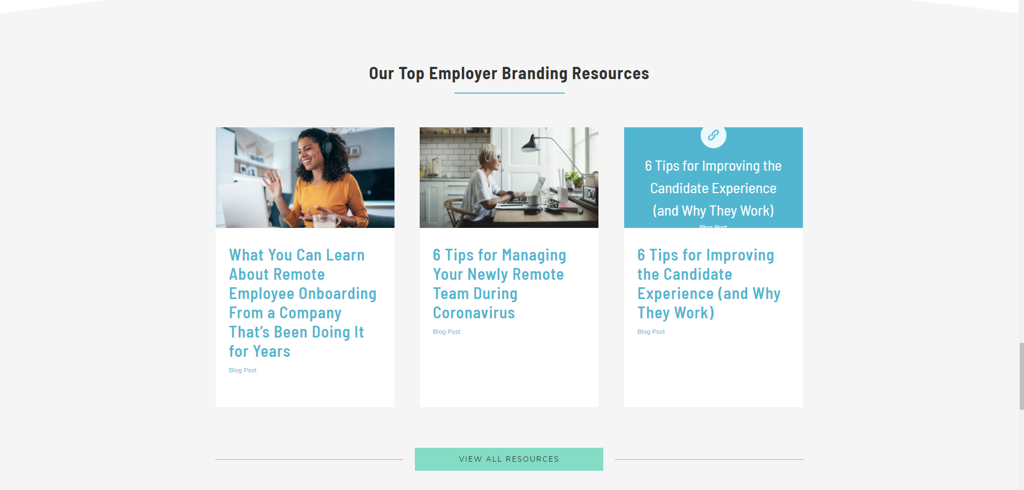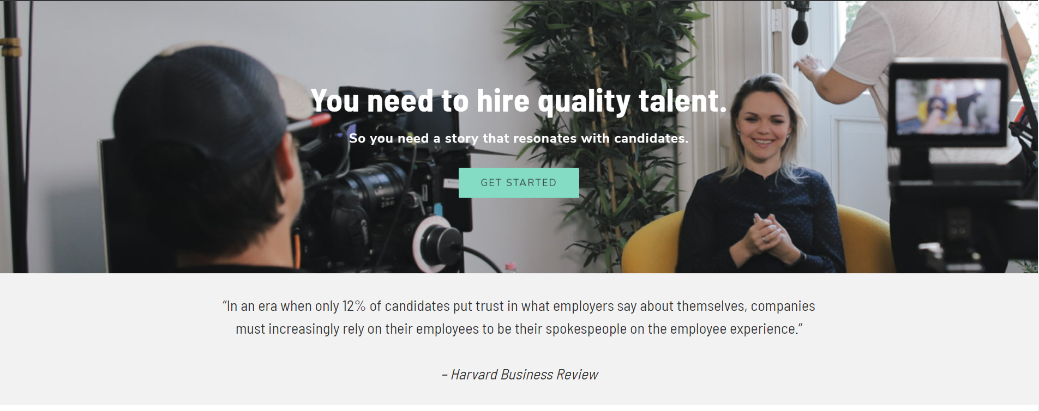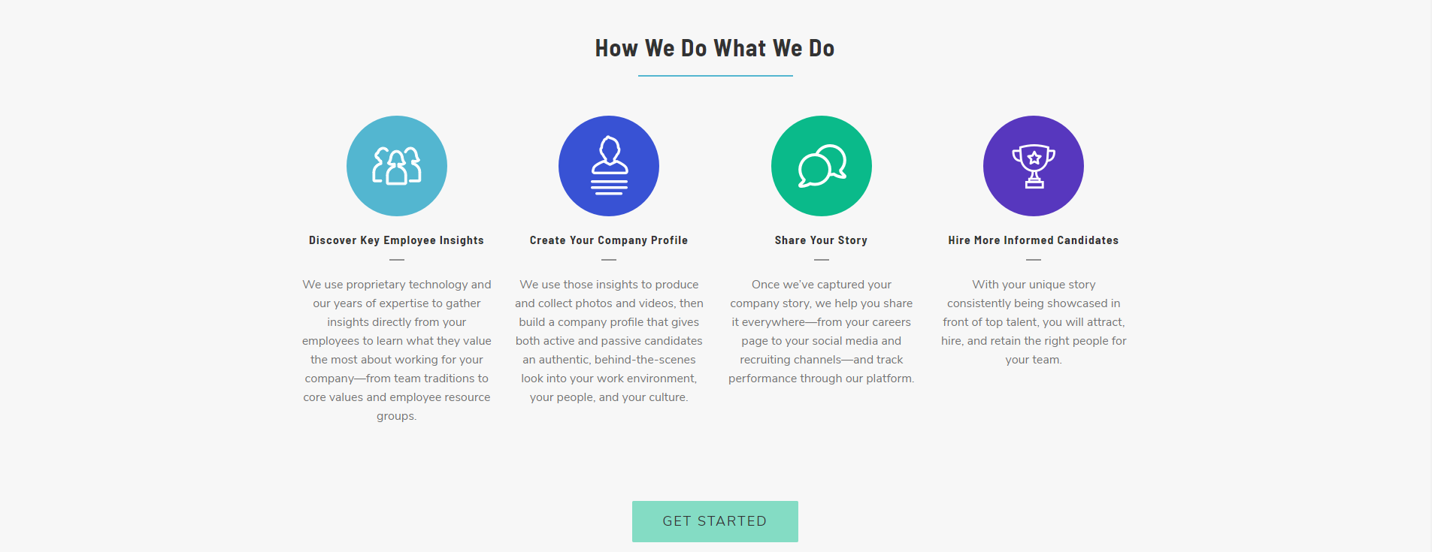

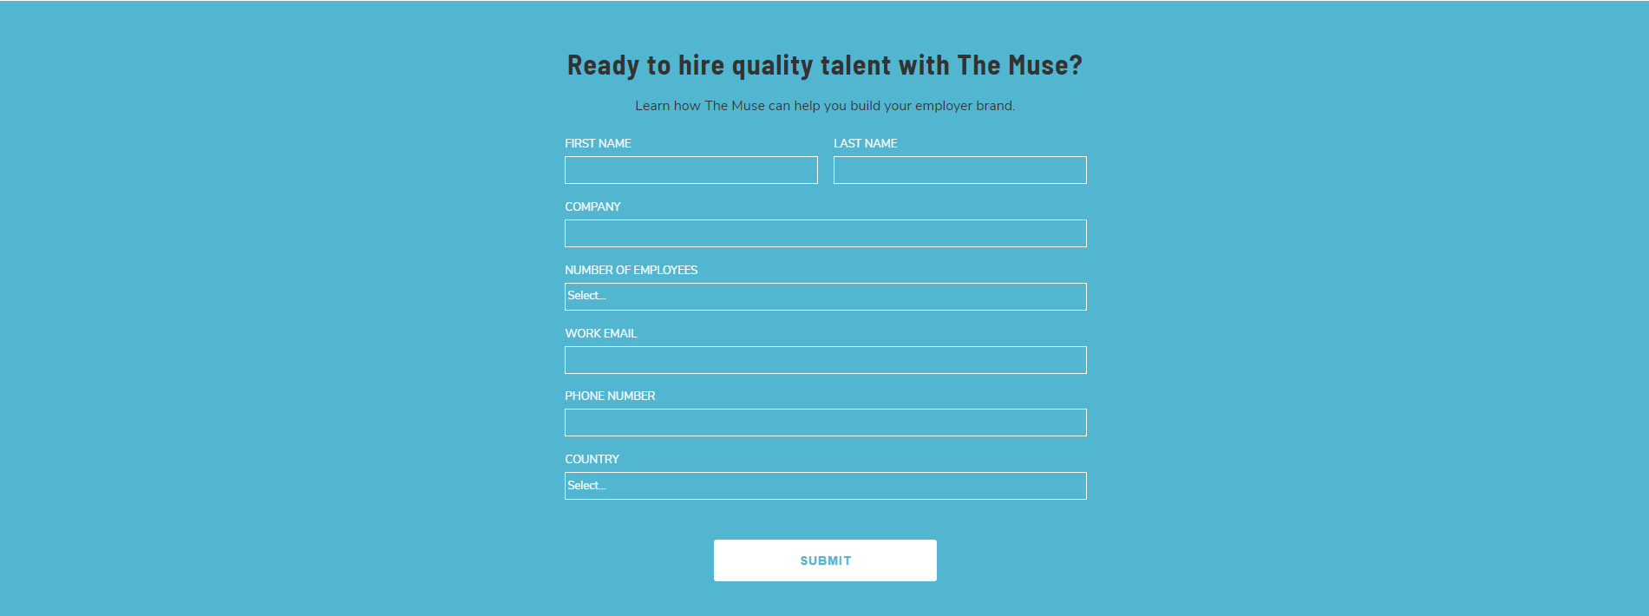

Interviews are taken by professionals interviewers from industry. Interviews will be taken to accommodate the job you are applying for. A detailed feedback will be given with chances of your hiring and suggestion for further improvement.